File System Setup

Find server in Commcell, expand file system folder, click on default folder, right click and choose properties,

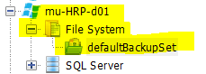

Be sure the “Use VSS” box is selected

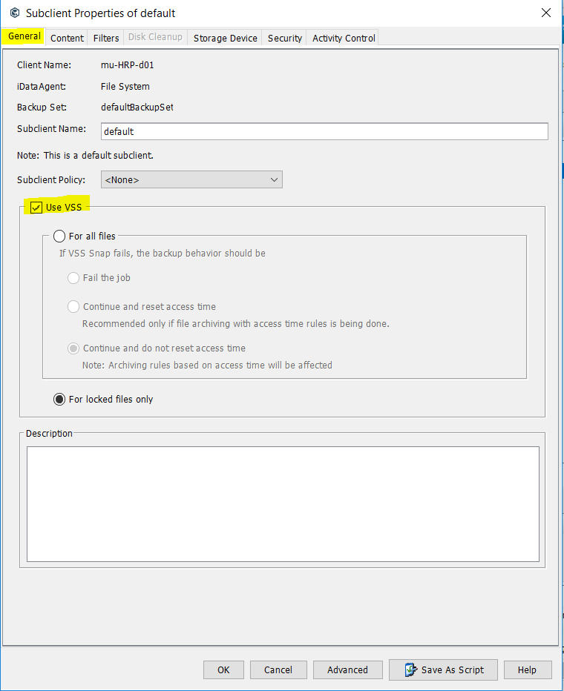

(Moved C:, D: to VM for File System)

Choose the filter Tab, Click Add and enter the below

\*.bak

\*.ldf

\*.mdf

\*.ndf

\*.old

\*.trn

C:\

D:\

P:\

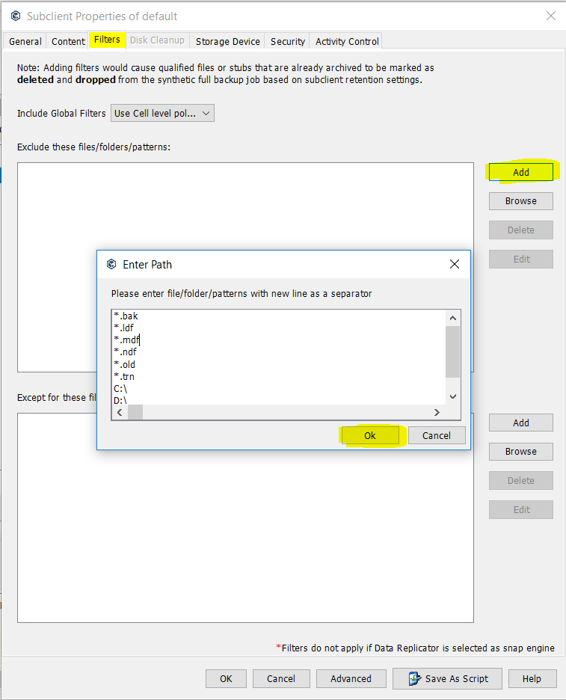

In the “Include Global Filters” select “ON” from the dropdown (Off)

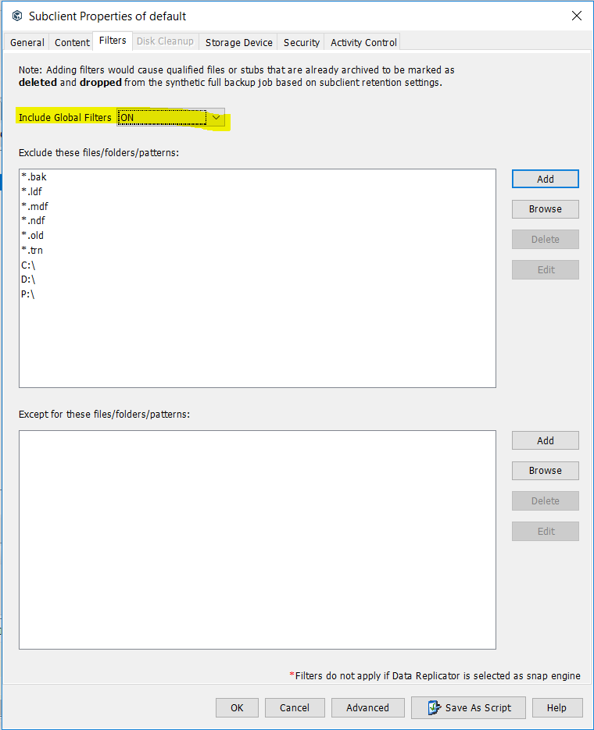

Choose the Storage Device Tab, under the “Data Storage Policy” tab, is where you choose the media agent, usually SF01 or SF05. I’m using SF01 in this case

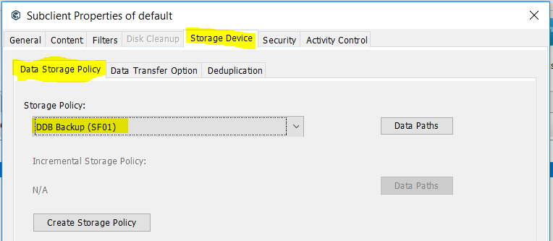

Select “Data Transfer Option” tab. Select “onClient”

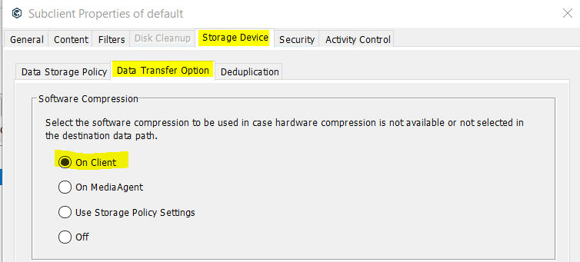

Select “Deduplication” tab, should leave like below. Hit “OK button”

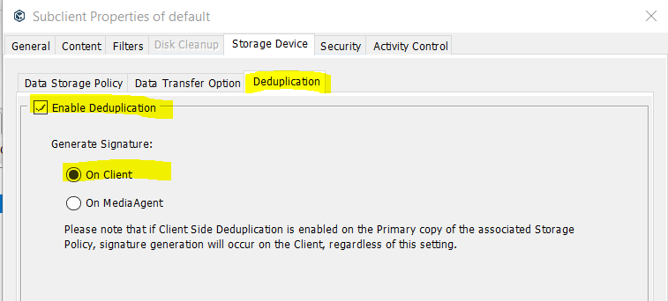

Scroll down to “Policies.” Expand policies, click on schedule policies, depending on test, dev or prod server, scroll to find the group type of server you are installing. Example, this server is mu….

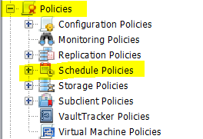

The “Associated Clients” columns list displays the max amount of servers for that schedule. Example, the the mu group, the max allowed is 10. On the selected group in blue there is only 1 server currently in there, so I chose this one.

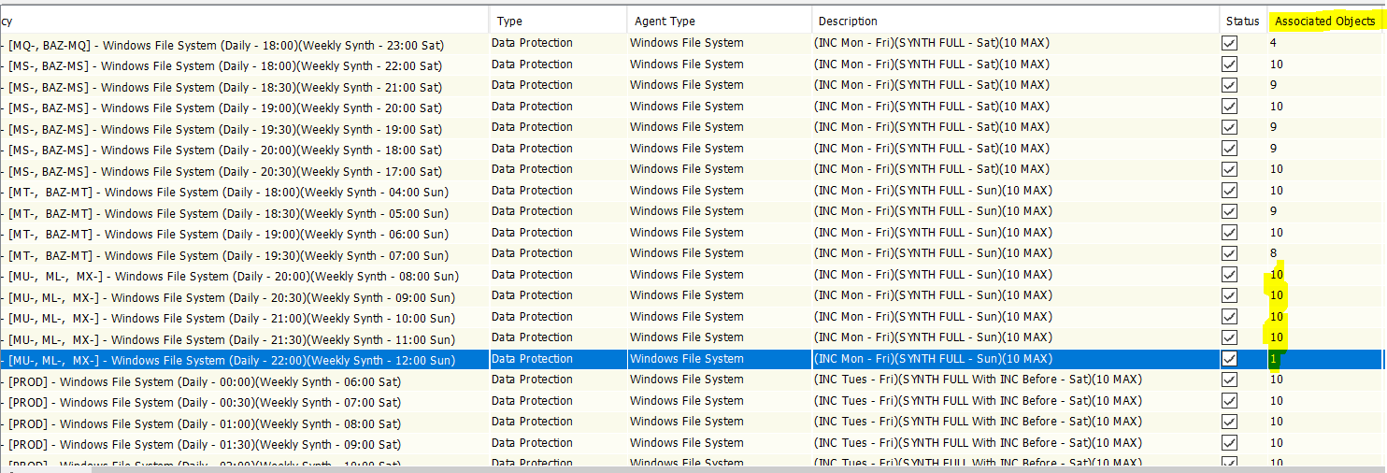

Right click the schedule you chose, edit, click on the “Associations” tab, then click the “edit” tab, find the server you chose and select it, then click ok.

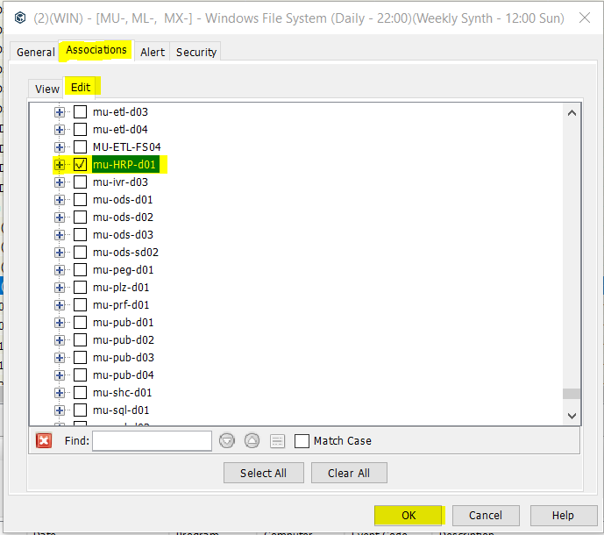

Verifying Schedules:

Find the server, right click, view, Schedules and you should see something similar to below.

